Automated YouTube Content & Scheduling Workflow
Make.com | YouTube | Google Drive | Google Sheets | Airtable | AI

Project Overview
Built a fully automated YouTube content system that handles video uploads, SEO content generation, validation, scheduling, and publishing through Make.com.
The workflow takes a video with basic content details and automatically prepares and schedules it for YouTube without requiring manual uploads or YouTube Studio work.
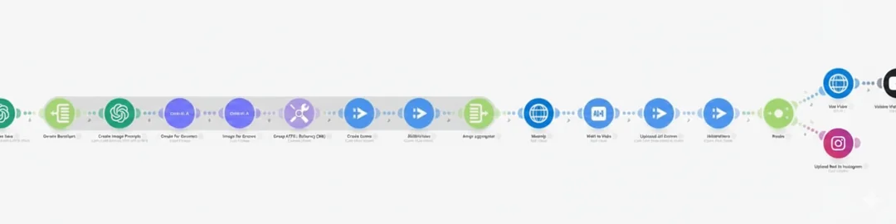

Workflow
The system:
- Retrieves video files and content details from Google Drive, Google Sheets, or Airtable
- Generates YouTube titles using AI
- Creates SEO friendly video descriptions
- Generates relevant hashtags
- Validates title length, description structure, and hashtag limits
- Stops or alerts the workflow when content does not meet the required criteria
- Uploads videos automatically to YouTube
- Applies the generated metadata and visibility settings
- Schedules videos with predefined publishing gaps
- Queues multiple videos for future publishing
- Logs the completed process and results

Content & Scheduling
The workflow automatically prepares each video for publishing and schedules content in advance.
Videos can be queued with predefined intervals such as every 7 to 10 days, allowing weeks or months of content to be scheduled at once.
The same automation can also branch into additional actions such as Instagram Reels publishing, Slack or email notifications, and Google Sheets reporting.

Content Management
The workflow uses Google Drive, Google Sheets, or Airtable as the central content source.
Each video can include:
- Video file
- Topic
- Keywords
- Publishing schedule
- Generated title
- SEO description
- Hashtags
- Publishing status
This keeps the complete YouTube content pipeline organized and easy to manage.

Technology
- Make.com
- YouTube API
- Google Drive
- Google Sheets
- Airtable
- AI
- Automated Scheduling
- Content Validation

Result
A complete automated YouTube publishing pipeline that handles content preparation, SEO, validation, uploading, and scheduling with minimal manual work.
The system makes it possible to prepare and queue weeks or months of YouTube content in advance while keeping the entire publishing process organized through automation.

